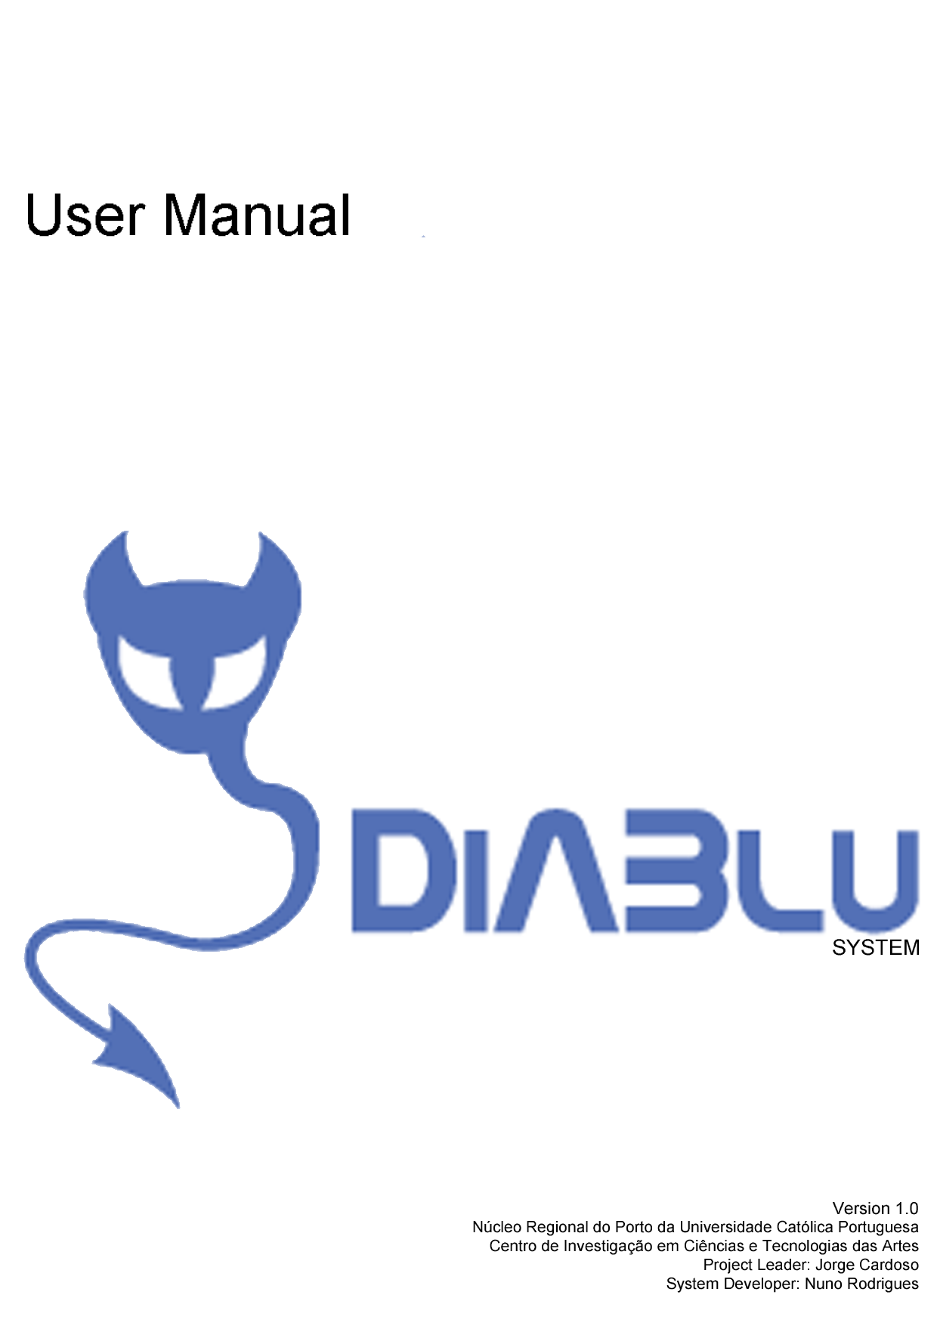

Our Many Thanks

Our work couldn’t have been done without the help and support of many others, here we express our many thanks to:

Moritz Gmelin from Avetana for it’s quick support on found issues with the Mac OS and the Avetana Bluetooth Stack
(http://www.avetana-gmbh.de/avetana-gmbh/produkte/jsr82.eng.xml)

Hanns Holger Rutz from NetUtil for it’s support and open source Java OSC API
(http://sourceforge.net/projects/netutil)

Paul Tötterman and James Scott from BlueCove for their support and open source Java Bluetooth Stack
(http://sourceforge.net/projects/bluecove/)

…and, of course, to all our work friends at CITAR

The DiABlu Team:

Jorge Cardoso, Nuno Rodrigues
index

Our Many Thanks 2
Introduction 4
What is CITAR ? 4
What is DiABlu Project ? 4
Installation 5
DiABlu Server Beta 5
DiABlu Mobile Beta 5
Interface 6
DiABlu Server Beta 6
DiABlu Mobile Beta 7
Use Cases………………………………………………………………………………….8
DiABlu Server 8
Discovery 8
Service 8
Simulation 9
Add simulated devices 9
Remove simulated devices 9
Edit simulated devices 9
DiABlu Mobile 10
Send a message 10
Send keys 10
Output………………………………………………………..……………………………11
Open Sound Control 11

Introduction

What is CITAR ?
Citar is a research unit of Portuguese Catholic University located at the Regional Center of Oporto. Citar's mission is to foster scientific research, through art, science and technology.

The center hosts and promotes interdisciplinary studies by fostering work developed together by artists, scientists and engineers with different backgrounds, knowledge, and cultures to create art, audiovisual objects and technologies.

What is DiABlu Project ?
The DiABlu System is an application that detects the presence of Bluetooth enabled devices and communicates their names and ids to other applications.
It's intended to be used in art instalations by digital artists who wish to give their audience a novel way to interact with their pieces.
Besides informing the application of the names of the currently present devices, the DiABlu system has also a mobile application that can be installed in a Java enabled phone that will allow the user to transmit data to the final application.
The system communicates via the OSC protocol so that applications written in Max/MSP, Pure Data, Processing, Flash, or any other with OSC support , will be able to use this system.
DiABlu is a project conceived by Jorge Cardoso at the School of Arts of the Portuguese Catholic University and it's being developed by Nuno Rodrigues at the Research Center for Science and Technology in Art (CITAR)

Installation

DiABlu Server Beta
To install the DiABlu Server you simply need to follow 3 simple steps:

1 – DiABlu Files
Unpack the downloaded zip file into the directory of your choosing.

2 – JSR82 Library
Simply place the .jar file into dist\lib folder under the chosen folder in step 1
[TODO:place the library’s check compatibility]

3 – Execute
Type java –jar citar.jar

4 – Have fun

DiABlu Mobile Beta
The DiABlu Mobile is even simpler to install. Simply select the DiABluMobile.jar, and use the context sensitive menu of your operating system to send it to your device.

Windows XP SP2 example
1 – Select DiABluMobile.jar
2 – Click on the right button
3 – Select “Send > Bluetooth Device”
4 – Select your device from the list or follow the steps in order to find him out
5 – Use your mobile device’s wizard in order to complete installation
6 – Ready to run. Go for it…
Interface

DiABlu Server Beta
A simple front-end interface, with four main panels: Detection, Simulation, Settings & Log with all the available features of each.
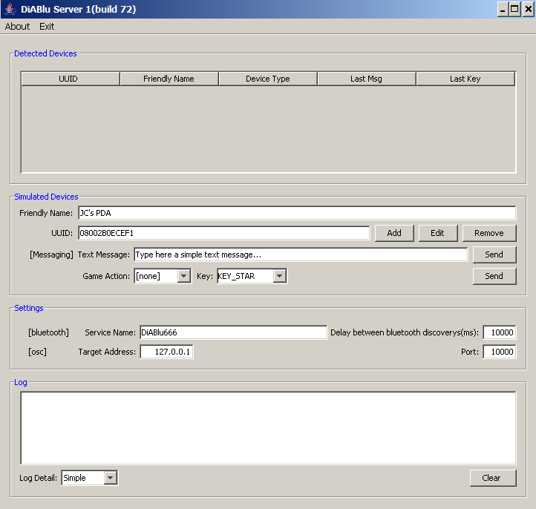
Set log detail (Simple (recommended) | Detailed | Errors Only)
Clear log
Bluetooth Delay & Service Name
Detected & Simulated devices information
DiABlu Simulator
Manage simulated devices
Send simulated msgs and keys
Target application address & port

DiABlu Mobile Beta
The Mobile version has a main view from which you can access all the available features

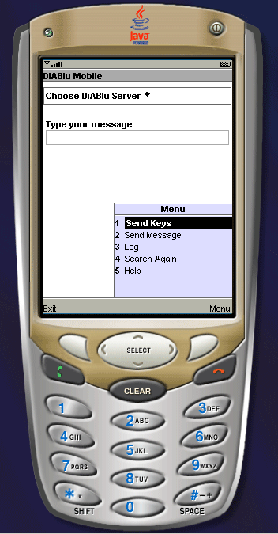
Choose the DiABlu Server
If you wish to send a text message you have to type here first
Change to the keyboard sensor mode
Check the log. If you’re having problems this might help
Send the typed message
Look again to find DiABlu Servers in the surroundings
Need help ?
Use Cases

DiABlu Server

Discovery
The only thing a user can alter in the Bluetooth Device Discovery process, is the time delay between device inquiries. Inquiries are complete searches for Bluetooth devices in range. This parameter was included after some serious testing since sometimes doing to much device discovery’s will block the BT Stack and make the DiABlu Server Service invisible, and then unavailable, to the DiABlu Mobile users.

A delay of 10 seconds (10000ms) proved to be a reasonable number in tests, but you should test the system on the target machines in order to fine tune the acceptable performance.

If you’re only interested in doing some device discovery, you can freely change this value to 0 (zero) and benefit from the extra performance.

Service
The DiABlu Server in order to communicate with the DiABlu Client needs to set up a Bluetooth service that can be discoverable to mobile devices, this service can have a personalized name that can be set in the graphics user interface.

Simulation

Add simulated devices
First you need to fill the device’s information, such as the friendly name and universal unique identifier (UUID) them hit the Add button on your simulation panel

Remove simulated devices
Selected one or multiple devices in the detected devices table and hit the Remove button on your simulation panel

Note: It’s possible to remove “real” Bluetooth devices from the table, but remember that, unlike simulated ones, they might show up again in the next discovery round.

Edit simulated devices
Select the device you want to edit, change it’s parameters in the corresponding text fields (Friendly Name, UUID) and them hit the Edit button. The table will update on the spot.

DiABlu Mobile

Send a message
To send a message you have to do 2 things:

1 – Type the message in the textfield
2 – Select the “Send message” command

Send keys
To activate the keyboard sensor you simply have to select the “Send Keys” command. The application screen changes to a DiABlu logo image and all your keyboard keys will be sent to the DiABlu Server.
Once you are done, hit the “BACK” button to quit the “Send Keys” mode.

Not all the keys since some of your keys are reserved by your mobile specific operating system, and a couple of them serve as commands so you can get out of the “Send Keys” mode.
Output

Open Sound Control
The DiABlu System outputs its information by the Open Sound Control (OSC) protocol. Each “Fire Event” triggers the DiABlu to send OSC messages according to the nature of the event. The table below better illustrates this:

OSC Command | Fire Event | Reception | Message Format
/DeviceIn | n devices found | One OSC message per device | (ss) : (UUID)(Friendly Name)
/DeviceListIn | n devices found | Single OSC message with with data about all devices found | (ss*n) :(UUID-0) (Friendly Name-0)(UUID-1) (Friendly Name-1)...(UUID-n) (Friendly Name-n)
/DeviceOut | n devices exited | One OSC message per device | (ss) : (UUID)(Friendly Name)
/DeviceListOut | n devices exited | Single OSC message with with data about all devices | (ss*n) : (UUID-0) (Friendly Name-0)(UUID-1) (Friendly Name-1)...(UUID-n) (Friendly Name-n)
/MessageIn | Client sent a text message | Single message | (sss) : (UUID) (Friendly Name) (Message Text)
/KeyIn | User pressed a key | Single message | (ssss) : (UUID) (Friendly Name) (Key Pressed) (Game Action)
/DeviceList | New devices found or exited | Single message with all devices present (n) | (ss*n) : (UUID-0) (Friendly Name-0)(UUID-1) (Friendly Name-1)...(UUID-n) (Friendly Name-n)
/NameChanged | Device’s Friendly Name(s) has (have) changed | Single message | (ss) : (UUID)(Friendly Name)
/DeviceCount | Any previous event | Single message | (i) : (Total of devices present)

The “devicein” and the “deviceout” commands send an OSC Bundle with all the new or exited devices. Each packet contains a pair of strings with the UUID and the Friendly Name of each device.

The “devicesin” and the “devicesout” commands send the same information as the previous commands, but they arrive as a single message that concatenates all the pairs of strings into an OSC Message.

